APPENDIX O

TUITION SLIDING SCALES

WHAT YOU WILL FIND HERE

This Appendix will show you how to create and use one of two different sliding tuition scales. This would be of interest to you if you offer “discounts” to students/families based upon the number of classes taken or the number of hours in which a student/family is enrolled.

INTRODUCTION

Multiple Class Tuition Discount Many dance studios offer students and families a reduced price per class when enrolled in multiple classes.

For example, Wilma Adams is taking one Tap class at $60.00 per month. If she registers for another class, maybe a Jazz class, then that second class will not be $60.00, but rather $50.00, so the total is $110.00, or $55.00 a class instead of $60.00. And if she takes a third class, her tuition will be $150.00, which is $50.00 a class instead of the original $60.00. So . . . in this example, take one class and you pay $60.00; take three classes and each one is $55.00 instead. Studios do this in order to encourage students to take additional classes - classes they might not take if there were no discount offered.

Number of Hours Tuition Discount Some dance studios offer students and families a reduced price per hour based upon the number of hours the student /family is taking (as opposed to the number of classes being taken).

For example, Andrea Gorman is enrolled for one hour a week, and her tuition is $44.00 a month. That’s $44.00 per hour. If she takes 2 hours a week, her tuition is $64.00 a month, or $32.00 an hour instead of $44.00 an hour. If she takes four hours a week, her tuition is $102.00 a month, or $25.50 an hour instead of $44.00 an hour. And if she takes seven hours a week, her tuition is $147.00 a month, which is $21.00 an hour instead of $44.00. The idea is that the more hours the student takes, the less is the cost per hour. Take one hour; you pay $44.00 an hour. Take seven hours; you pay half that ($21.00 an hour). Again, studios do this in order to encourage students to enroll in additional hours - hours they might not take if there were no discount offered.

You can configure CompuDance to conform to either one of the above discount policies. You can’t combine the policies. You must select one. Based upon your tuition policy, you will use one of two CompuDance Tuition Scales.

Please note that the amounts in the above hypothetical situations are used as examples only. You can have any amounts you wish.

Tuition Scale 1 This scale is for studios that offer discounts based upon the number of classes a student/family is taking.

Tuition Scale 2 This scale is for studios that offer discounts based upon the number of hours a student/family is taking.

HOW TO CREATE TUITION SCALE 1

If you have a policy that provides discounts for students/families based upon the number of classes in which they are enrolled, then you will use Tuition Scale 1.

Procedure

Step 1 In the Menu Bar of the CDW Main Window, click Configuration. Click the Tuition Scale 1 tab.

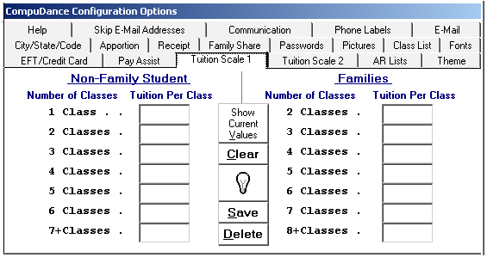

Step 2 The left side of this Configuration tab references the total classes taken by a non-family student. Enter the tuition
charge per class based upon the number of classes in which a student is enrolled. Press <Enter> after each entry.
Do not use the $ sign. To enter $45.00, simply type [45] <Enter>.

The right side references the total number of classes taken by a family, regardless of the number of students in the
family. If Anne Brown is in three classes, and Mary Brown is in two class, then the total number of classes for the
family is five classes.

Individual Student Assume you have a policy that the tuition for a single class is $45.00. However, if a student takes additional classes, she/he is offered a discount. For example, if a student takes two classes the total tuition might be $80.00 instead of $90.00, which is $40.00 a class instead of $45.00. If a student takes three classes, the total could be $105.00, which is $35.00 a class; four classes might be $120.00, or $30 a class. After the fourth class let’s assume that each class is $25.00.

Family Assume your policy also relates to families. The tuition for a family taking a total of two classes is $75.00, or $37.50 a class. However, if the total is three classes, the tuition is $97.50, which is $32.50 a class instead of $37.50. If the family takes a total of four classes, the total is $112.00, which is $28.00 a class. After the fourth class let’s assume that each class is $25.00. Here is how you would configure Tuition Scale 1 based upon the above two paragraphs.

1 Class . . 45.00 2 Classes . 37.50
2 Classes . 40.00 3 Classes . 32.50
3 Classes . 35.00 4 Classes . 28.00
4 Classes . 30.00 5 Classes . 25.00
5 Classes . 25.00 6 Classes . 25.00
6 Classes . 25.00 7 Classes . 25.00
7+ Classes . 25.00 8+ Classes . 25.00

If you set up your scale like that, CompuDance will automatically calculate tuition for each student based upon the number of

classes the student is taking and the sliding scale that you create in this Configuration Tab. It will enter that amount for you in the Tuition Text Box on each SRD and FRD. Each time a student adds or drops a class, or each time a new student is added to or a current student is deleted from a family, CompuDance will instantly re-calculate the new tuition and enter the amount for you in the appropriate SRD and/or FRD. This can save you much time, especially at those times when students are constantly adding and dropping classes.

Remember that the above specific situations are simply for illustrative purposes only. We realize that there are a variety of ways a studio owner could configure this scale when giving discounts for students taking multiple classes, and for families taking many classes.

If you wish CompuDance to use this function, you need to make an entry that is greater than zero in each text box on both sides. If there are no entries in the scale, then CompuDance will not calculate and enter tuition in the SRD or FRD based upon the number of classes taken. You will have to manually enter each student and each family tuition amount in the Tuition Text Box in each SRD and FRD and update it yourself. Or, you can use Tuition Scale 2 as described on the next page to have CompuDance calculate tuition based upon hours enrolled.

HOW TO CREATE TUITION SCALE 2

If you have a policy that provides discounts based upon the number of hours a student/family is taking, then you will use Tuition Scale 2.

Procedure

In the Menu Bar of the CDW Main Window, click Configuration. Click the Tuition Scale 2 tab.

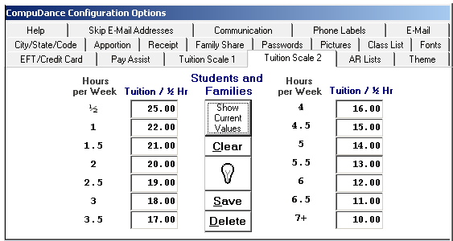

This scale is based upon the number of hours a student is taking or the number of hours a family is taking. There is no distinction between hours for students as opposed to hours taken by an entire family. In that sense, this scale is a little different from Tuition Scale 1 where there was a distinction between students and families. The scale calculates the tuition cost based upon price per 1/2 hour, regardless of whether you are calculating tuition for an individual student or for a family. This is where you can set up that sliding scale.

The scale above is filled in reflecting the following hypothetical situation. You have a policy that the tuition for taking one hour per week is $44.00 ($22.00 per half hour). However, if a student/family takes two hours a week, the tuition is $80.00 instead of $88.00 (which is only $20.00 per half hour instead of $25, or $40.00 per hour instead of $44.00). Then if the student/family is in class for three hours a week, the total tuition is only $108.00 ($18.00 per half hour, or $36.00 an hour instead of $44.00 per hour). So . . . the more hours a student takes, the less he/she pays per hour. This is similar to the concept on which Tuition Scale 1 is based.

The reason CompuDance breaks the scale into half hour segments is because many studios have classes that are 45 minutes, 30 minutes, 90 minutes, 120 minutes, etc. Not all have just 60-minute classes.

You enter the tuition amount per half hour in each of 14 test boxes above corresponding to the following formula:

1 No. of Minutes per Week is > 0 and <60 8 No. of Minutes per Week is >= 240 and <270
2 No. of Minutes per Week is >= 60 and <90 9 No. of Minutes per Week is >= 270 and <300
3 No. of Minutes per Week is >= 90 and <120 10 No. of Minutes per Week is >= 300 and <330
4 No. of Minutes per Week is >= 120 and <150 11 No. of Minutes per Week is >= 330 and <360
5 No. of Minutes per Week is >= 150 and <180 12 No. of Minutes per Week is >= 360 and <390
6 No. of Minutes per Week is >= 180 and <210 13 No. of Minutes per Week is >= 390 and <420
7 No. of Minutes per Week is >= 210 and <240 14 No. of Minutes per Week is >= 420

The symbol >= means greater than or equal to.

Lets look at a few examples based upon the Tuition Scale 2 and the formula on the previous page. If a student is in one 45 minute class a week, the tuition is based upon the amount you enter per half hour in Text Box 1; because 45 minutes is greater than 0 and less than 60 minutes. The tuition would be $25.00.

If a student is in class for 2.5 hours a week, the tuition is based upon the amount you enter per half hour in Text Box 5; because 2.5 hours is equal to 150 minutes and less than 180 minutes. The tuition would be $95.00 (5 x 19 = 95).

If a family has three students in class for a total of 6 hours and 45 minutes a week, the tuition would be based upon the amount you enter per half hour in Text Box 13; because 6 hrs and 45 min is 405 minutes, which is greater than 390 minutes and less than 420 minutes. The tuition would be $154.00 (13.5 x 11 = $148.50).

Remember, these are just hypothetical examples used to demonstrate the scale. You can use any amounts you want.

If you wish CompuDance to use this function, you need to make an entry that is greater than zero in every text box. If there are no entries in the scale, then CompuDance will not calculate and enter tuition in the SRD or FRD based upon the number of hours for which a student/family is enrolled. You will have to manually enter each student and each family tuition amount in the Tuition Text Box in each SRD and FRD and update it yourself. Or, you can use Tuition Scale 1 as described earlier in this Appendix.

When making an entry do not use the $ sign. You do not have to enter the .00 when the dollar figure is even. You must press <Enter> after typing an amount!

HOW TO SELECTIVELY BY-PASS A TUITION SCALE

When you have completed one of the tuition scales, CompuDance will then automatically calculate all student and all family tuition amounts for you. However, you can ask CompuDance to skip the calculation process for certain selected student and families. Here is how you would do that.

Assume that you have filled out and are using one of the Tuition Scales, but you have one or more students or families for whom you want to calculate tuition manually. For example, your daughter has no tuition; your secretary’s daughter pays for only one class; an advanced student helps you with a baby class, and you give her free tuition. CompuDance can easily handle as many of these type of exceptions as you need.

If you want CompuDance not to calculate tuition for a student, simply enter the letter “Z” [Z] in the code text box. When CompuDance calculates tuition, if it sees a Z in the Code Field, it will skip that student.

If you want CompuDance not to calculate tuition for a family, simply enter the letter “Z” [Z] as the first entry in the family Miscellaneous Text Box. When CompuDance calculates tuition, if it sees a Z as the first character in the Miscellaneous Field, it will skip that family.

Remember, once you remove that Z, CompuDance will again automatically calculate the tuition amount based upon the operative Tuition Scale.

